Exchange Culture • Experience shanghai
2016 Shanghai Summer School
Shanghai University

Program Highlights:

- Lively and effective Chinese language courses
- Lecture series & culture practice for personal participation to experience & understand Chinese culture essence
- A variety of visits & exchange activities to explore the spirits of modern China city represented by Shanghai
- A field investigation to “China's most famous paradise on earth” (Suzhou and Hangzhou) to feel the charm of China's South Yangtze River Delta.
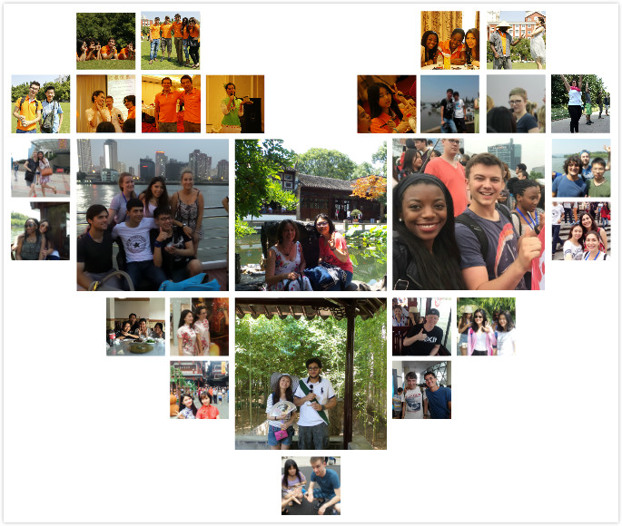

1. Project Information
1.1 Time
July 18, 2016—August 14, 2016, 4 weeks in total
1.2 Project Content
Module | Theme | Form | Class Hour | Remarks
Chinese Language | Spoken Chinese & Conversation | Classroom Teaching | 36 | Delivered by leading Chinese language teacher
 | Chinese Language Communication &Techniques | Out classroom Practice | 6 | Accompanied by Chinese students in groups
Culture- Chinese Culture under the background of Globalization | Globalization | Lecture | 3 | Delivered by senior professor of Shanghai University
 | Chinese Culture | Lecture | 3 | Delivered by senior professor of Shanghai University
 | Chinese Tea Culture | Lecture | 3 | On-site explanations by tea house lecturer
 | Chinese Calligraphy Culture | Lecture | 3 | Delivered by expert from Academy of Fine Arts
 | Chinese History | Visit & Experience | --- | Visit Shanghai Museum
 | Chinese Martial Arts | Visit & Experience | --- | Visit the Museum of Chinese Martial Arts
 | Traditional Chinese Medicine Culture | Visit & Experience | --- | Visit Shanghai Museum OF TCM
 | Chinese Costume | Visit & Experience | --- | Visit Textile and Costume Museum
 | Chinese Folk Culture | Visit & Experience | --- | Visit Folk Culture Museum
 | Confucius Culture | Visit & Experience | --- | Visit Confucius Temple in Jiading District
 | Traditional Culture of south of the Yangtze River | Field investigation | --- | Zhujiajiao Ancient Town
 |  |  | --- | Two-day trip to Suzhou and Hangzhou
Cross Culture Exchange:  China Door – Open Shanghai | Topic 1 International Metropolis -- Shanghai | Lecture | 3 | Delivered by senior professor of Shanghai University
 |  | Visit & Experience | --- | Shanghai Urban Planning Exhibition Hall
 |  | Visit & Experience | --- | Oriental Pearl TV Tower, Lujiazui
 |  | Visit & Experience | --- | Huangpu River Cruise
 |  | Exchange & Experience | --- | Cross Culture Exchange Meeting
 | Topic 2  International Economic Center -- Shanghai | Lecture | 3 | Delivered by senior professor of Shanghai University
 |  | Visit & Experience | --- | Yu Garden
 |  | Visit & Experience | --- | Bao Steel
 |  | Visit & Experience | --- | Coca Cola
 |  | Exchange & Experience | --- | Cross Culture Exchange Meeting
 | Topic 3 International Cultural Center -- Shanghai | Lecture | 3 | Delivered by senior professor of Shanghai University
 |  | Visit & Experience | --- | Acrobatic Show
 |  | Visit & Experience | --- | Tianzifang, Xintiandi
 |  | Exchange & Experience | --- | Visiting top universities
 |  | Exchange & Experience | --- | Cross culture exchange activity in Daning International Community
Summarize & Report | Summarize and Report Achievements | Achievement Exhibition | --- | Photography, paintings, essays, videos, reports and so on
The project content is subject to change according to the actual arrangements.

1.3 Schedule （The schedule is subject to change according to the actual arrangements. ）
Date |  |  |  | Time |  | Event |  | Remark
July 17 | Sunday |  |  |  |  | Arrival
July 18 |  | Monday |  | 9:00-11:00 |  | Registration, Orientation
 |  |  |  | 11:30-12:30 |  | Opening ceremony, welcome lunch |  | School Canteen
 |  |  |  | 13:30-15:30 |  | Campus Tour, get to know the living surroundings
July 19 |  | Tuesday |  | 9:00-11:40 |  | Spoken Chinese & conversation
 |  |  |  | 13:30-15:50 |  | Lecture: Globalization
 |  |  |  | 15:30-21:30 |  | Visit Oriental Pearl TV Tower, Lujiazui; Huangpu River Cruise |  | Dinner at Chinese style restaurant
July 20 |  | Wednesday |  | 9:00-11:40 |  | Lecture: International Economic Center -- Shanghai
 |  |  |  | 13:30-16:30 |  | Shanghai Museum & Shanghai Urban Planning Exhibition Hall
July 21 |  | Thursday |  | 9:00-11:40 |  | Spoken Chinese & Conversation
 |  |  |  | 13:30-15:30 |  | Cross Culture Exchange Meeting
Date |  |  |  | Time |  | Event |  | Remark
July 22 |  | Friday |  | 9:00-11:40 |  | Spoken Chinese & Conversation
 |  |  |  | 13:30-15:30 |  | Lecture: Chinese Culture
July 23 |  | Saturday |  | 9:00-15:30 |  | Visit Confucius Temple in Jiading District |  | Lunch at Chinese style restaurant
July 24 |  | Sunday |  | 9:00-15:30 |  | Visit Zhujiajiao Ancient Town |  | Lunch at Chinese style restaurant
July 25 |  | Monday |  | 9:00-11:40 |  | Spoken Chinese & Conversation
 |  |  |  | 13:30-15:30 |  | Lecture: Chinese Tea Culture |  | Tea House
July 26 |  | Tuesday |  | 9:00-11:40 |  | Lecture: International Cultural Center -- Shanghai
 |  |  |  | 13:30-16:30 |  | Chinese Martial Arts Museum
 |  |  |  | 18:30-21:30 |  | Acrobatic Show
July 27 |  | Wednesday |  | 9:00-11:40 |  | Spoken Chinese & Conversation
 |  |  |  | 13:30-16:00 |  | Visit Textile and Costume Museum
July 28 |  | Thursday |  | 9:00-11:40 |  | Chinese Language Communication and Techniques |  | Communicate with Shanghai citizens in the market
 |  |  |  | 13:30-15:30 |  | Lecture: Chinese Calligraphy & Painting
July 29 |  |  | Friday |  | 9:00-11:40 | Spoken Chinese & Conversation
 |  |  |  |  | 13:00-15:30 | Visiting top universities
July 30 |  |  | Saturday |  | 9:00-11:40 | Chinese Language Communication and Techniques |  | Communicate with Shanghai citizens in the park
 |  |  |  |  | 13:30-15:30 | Cross culture exchange activity in Daning International Community
July 31 |  |  | Sunday |  | 9:00-16:30 | Visit Yu Garden, Tianzifang, Xintiandi |  | Dinner of special characteristics
August 1 |  |  | Monday |  | 9:00-11:40 | Spoken Chinese & Conversation
 |  |  |  |  | 13:30-15:30 | Lecture: International Economic Center -- Shanghai
August 2 |  |  | Tuesday |  | Two-day trip of Suzhou and Hangzhou
August 3 |  |  | Wednesday
Date |  |  |  |  | Time | Event | Remark
August 4 |  |  | Thursday |  | 9:00-11:40 | Spoken Chinese & Conversation
 |  |  |  |  | 13:30-16:00 | Visiting famous company
August 5 |  |  | Friday |  | 9:00-11:40 | Spoken Chinese & Conversation
 |  |  |  |  | 13:30-16:00 | Visiting famous company
August 6 |  |  | Saturday |  | 9:00-16:00 | Quality Developing Activities in Oriental Land
August 7 |  |  | Sunday |  | 9:00-16:00 | Prepare for Final Report Show
August 8 |  |  | Monday |  | 9:00-11:40 | Spoken Chinese & Conversation
 |  |  |  |  | 13:30-16:00 | Shanghai Museum OF TCM
August 9 |  |  | Tuesday |  | 9:00-11:40 | Spoken Chinese & Conversation
 |  |  |  |  | 13:30-16:00 | Lecture: Chinese Calligraphy & Painting
August 10 |  |  | Wednesday |  | 9:00-11:40 | Cross Culture Exchange Meeting
 |  |  |  |  | 13:30-16:00 | Chinese Folk Culture Museum
August 11 |  |  | Thursday |  | 9:00-11:40 | Spoken Chinese & Conversation
 |  |  |  |  | 13:30-16:00 | Preparation of Achievements Report Show
August 12 |  |  | Friday |  | 9:00-11:40 | Wrap-up meeting and Achievements Report Show
 |  |  |  |  | 15:30-17:30 | Graduation Ceremony & Achievements Report Show
 |  |  |  |  | 18:00-20:00 | Graduation Dinner Party |  | Dinner of special characteristics
August 13 |  |  | Saturday |  |  | Depart from university
August 14 |  |  | Sunday |  |  | Final Departure

2. Application Information
2.1 Requirements for Applicants：
Students or company staff above 18 years old; University undergraduates or higher education level; possess Chinese and English language foundation; foreigners with non-Chinese passport
2.2 Application Deadline
June 1, 2016
2.3 Application Materials
Application Form
Passport copy
2.4 Application Procedures
2.4.1 Fill in the application form and send it back with copy of passport to the email address apply2@oa.shu.edu.cn before the deadline of June 1, 2016
2.4.2 Issue admission documents from June 15, 2016
3．About Visa
X2 visa (staying no more than 180 days)
or L visa (staying no more than 30 days) is accepted.
4. About Fees
4.1Bacis Package (Prices are quoted in CNY per person)

Fee | Contents | Details
RMB 8250 (Double room)  RMB 9700 (Single room) | application (RMB500) | visa documents; campus tour; welcome party; student ID card making
 | tuition (RMB2500) | Chinese Courses：RMB1800  including: 36 class hours in classroom and 6 class hours for language practice  7 lectures delivered in English：RMB 700
 | accommodation:  Double Room :RMB 1450  Single room: RMB 2900 | Cost per person per night is：  single room: 100RMB  double room: 50RMB  July 17, 2016—August 14, 2016 (29 days in all)
 | Activities (RMB 3800) | 4 Cross culture exchange activity: RMB 500  14 Visits related to lectures:  RMB 1800  2 Day-trip to Suzhou &Hangzhou: RMB 1500
4.2 Others (not included in Tuition)
Fee | Contents | Details
RMB 900 | meals in student cafeteria | Breakfast, lunch and dinner
RMB 1000 | Deposit for Dorms | refunded at check-out
RMB 400 | Pick up Service | For group pick-up (more than 2 students), we will provide this service for free.

5．Detailed Information
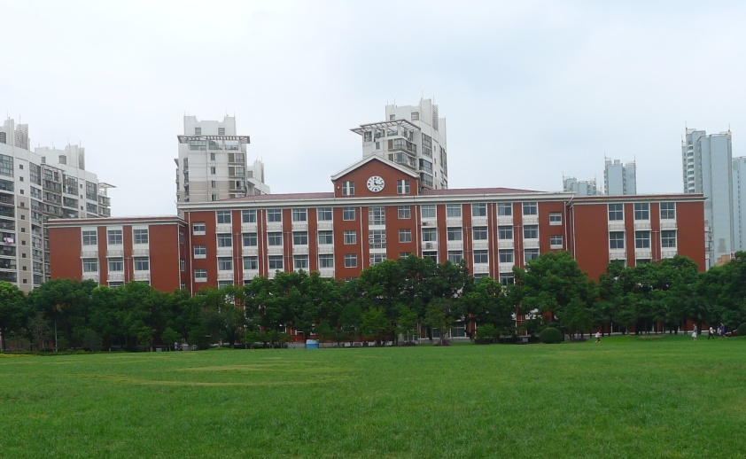
5.1 Dormitory
Double room in international students’ dorm, equipped with air conditioning, telephone, network interface, and separate bathroom facilities. There are public kitchens, laundry rooms and refrigerators in the dorm. The life is very convenient with restaurants, supermarkets and convenience stores near the dorm.
5.2 Campus Tour
Led by the teacher and accompanied by senior students of the same nationality, we will show you around the campus, including administration building, library and other facilities, and you will get to know the development and current situation of Shanghai University and gain an insight into the life of Shanghai University.
5.3 Welcome Party & Orientation
Dean of International of Exchange will attend in person; introduction of general information of Shanghai University and other matters needing attention.
5.4 Two-day trip of Suzhou and Hangzhou
“Just as there is paradise in heaven, there are Suzhou and Hangzhou on earth.”
Suzhou is China's most affluent city located in the northern wing of the Yangtze River Delta, It is also one of China's most famous scenic spots. Suzhou has always been renowned for its beauty scenery, elegant gardens in the world. As the saying goes “Gardens to the south of Yangtze River are the best in the world, and Suzhou gardens are the best among them”. Suzhou is also praised as the “Oriental Venice”, “Oriental Water Town” for its unique charming small bridges over the flowing steam. Attractions include Humble Administrator's Garden (Zhuozheng Yuan), Hanshan Temple (Cold Mountain Temple), Pan Gate. Expenses only include buses, tickets for main entrance, guide services, group meal and accident insurance.
(Website for reference: www.suzhou.gov.cn.) 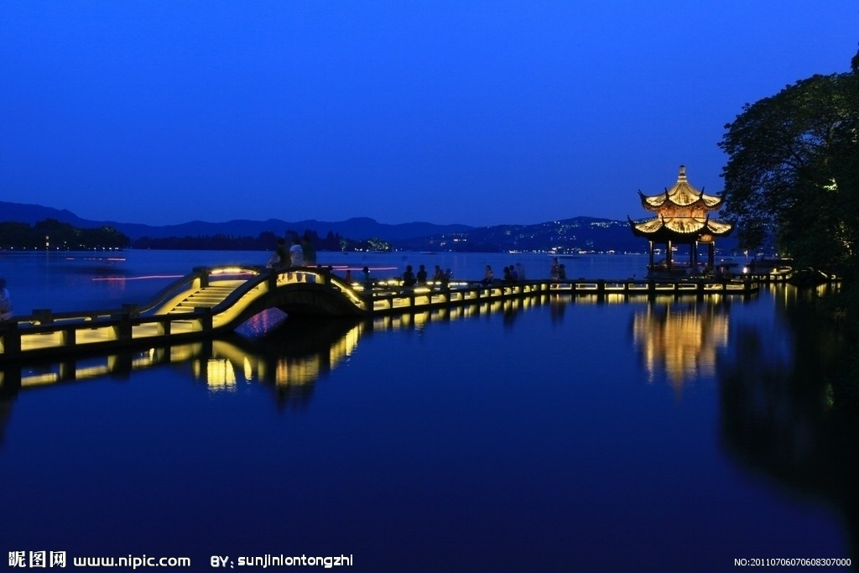
Located in the southern wing of River Delta, Hangzhou is one of the most famous scenic spots in China. It is always known as “A fertile land of fish and rice”, “Heaven on Earth” and “Capital of Silk”. Attractions include West Lake Scenic Area, Six Harmonies Pagoda, Longjin Area. Expenses only include buses, tickets for main entrance, guide services, group meals, common standard double room of three and four star hotel and accident insurance.
(Website for reference: www.hangzhou.gov.cn.)
5.5 Yu Yuan Garden Tour
Located in Huangpu District of Shanghai, Yu Garden is the private garden of Ming Dynasty. There are City God Temple and various Specialty shops in the garden including Shanghai Chopstick Shop, Umbrella Specialty Shop, Tiehuaxuan Pottery and Porcelain Shop and numerous famous restaurants such as Nanxiang Dumpling Restaurant (Shanghai juicy steamed buns), Lvbolang Restaurant (Shanghai light refreshments) and Shanghai Old Restaurant (Shanghai style dish). 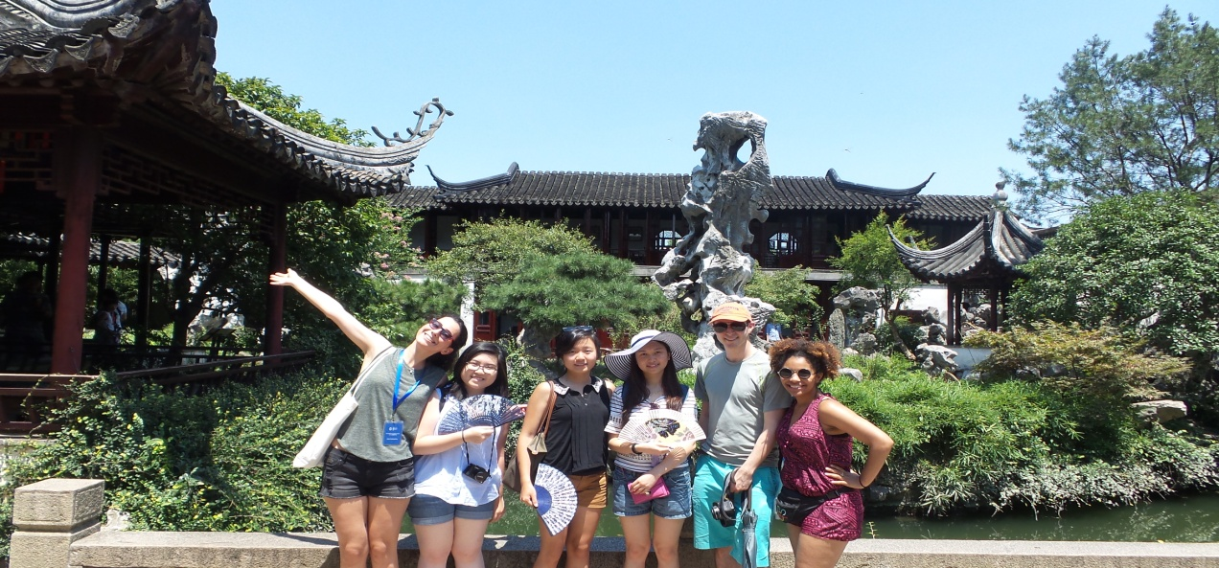
5.6 Watch acrobatics
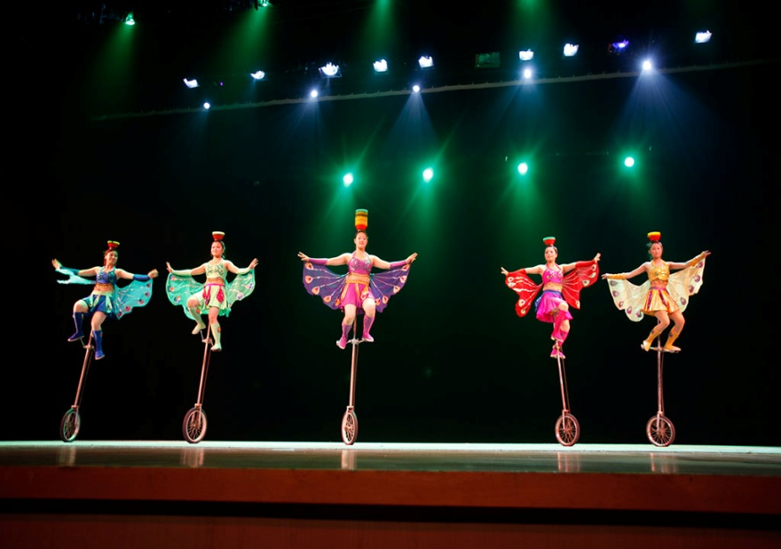
With the combination of different elements such as acrobatics, dance, drama, music and world-class multimedia technology and utilizing unique national art elements of Yangtze River Delta and intersection of time and space, “ERA Intersection of Time” shows the Chinese long history and splendid civilization through yesterday, today and tomorrow. The play is full of surprises and magical effects through the use of high technology. It can be regarded as “No.1 show of entertainment in China”.
5.7 Jinmao tower 88th floor Sightseeing
Across the Huangpu River with the famous Bund Scenic Area, Jinmao tower is situated in the prime location of Lujiazui Finance and Trade Zone in Pudong. It covers a total construction area of 230,000 square meters and is 420.5 meters high. It has 88 stories above the ground, three stories underground. It is the highest building in Asia and the third highest building in the world. With its modern and traditional trait, Jinmao Tower is a landmark representing Shanghai’s march forward to 21st century. 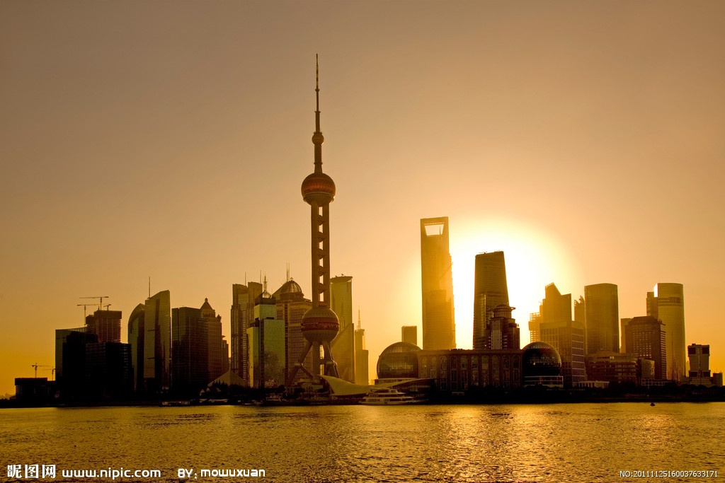

5.8 Huangpu River Cruise
Huangpu River Cruise is an important tourism activity of Shanghai. Huangpu River is not only Mother River of Shanghai but also the symbol and epitome of Shanghai. You can gain an insight into Shanghai’s past, present and brilliant future by cursing along the banks of Huangpu River where attractions concentrate.
5.9 Shanghai Museum of Textile and Costume
Shanghai Museum of Textile and Costume has Popular Science Exhibition, Ancient Exhibition, Modern Exhibition and Minorities Exhibition. It has more than 3000 square meter exhibition space. http://www.study-shanghai.org/School/Base01.asp 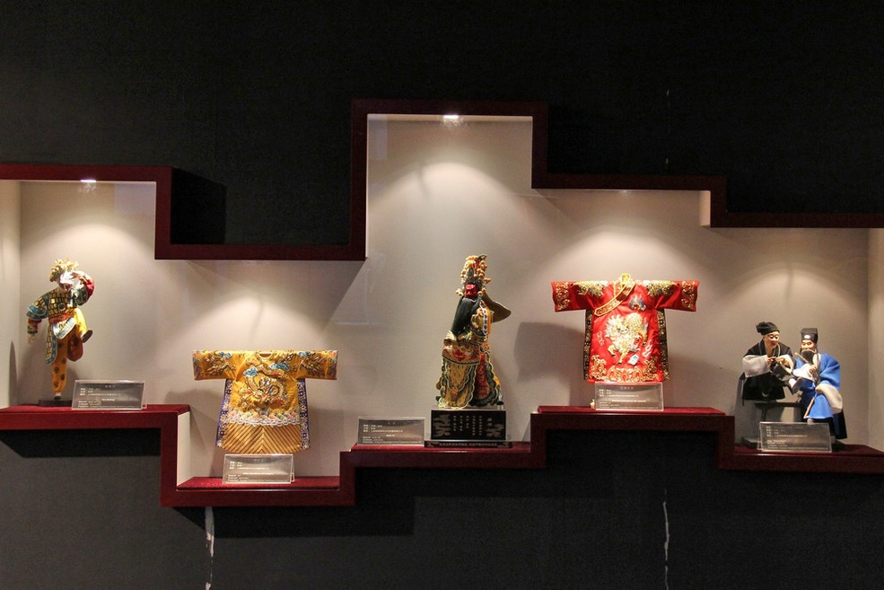
5.10 Shanghai Museum of TCM
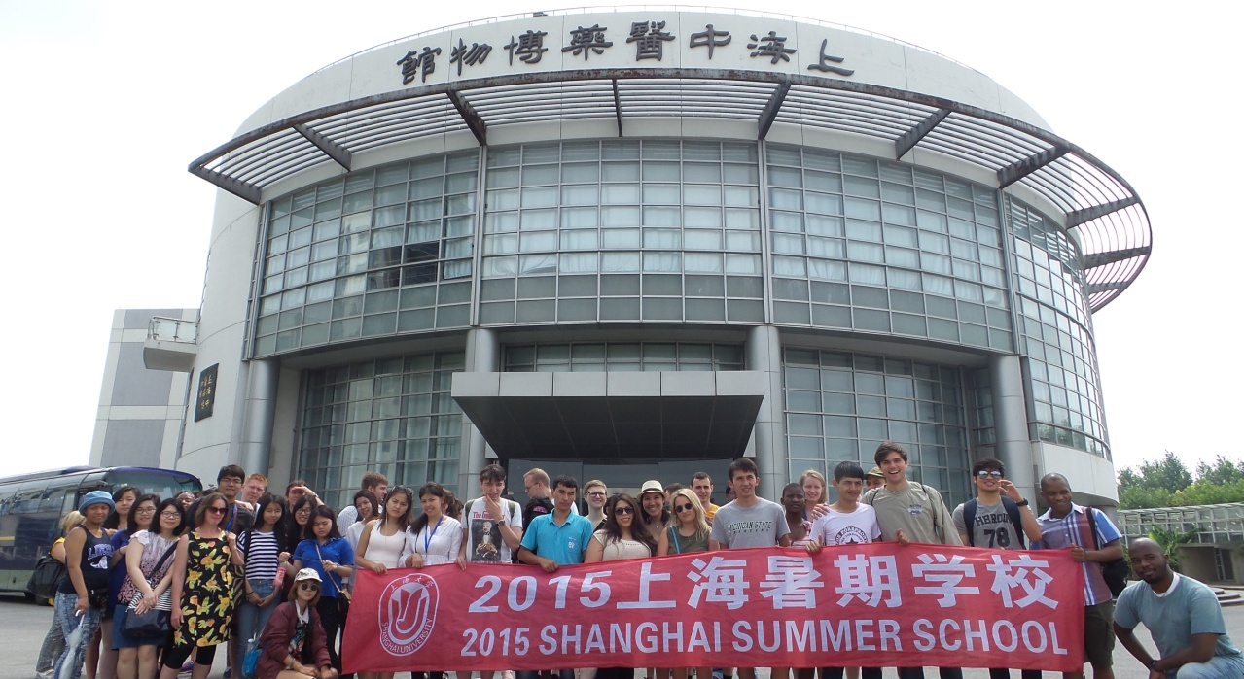
Shanghai Museum of TCM showcases the development of from creation to prosperity and from inherence to innovation of TCM. It is the epitome of broad and profound study and culture of Traditional Chinese Medicine. It is the specialized scientific and technological museum of colleges and universities. http://www.study-shanghai.org/School/Base02.asp
5.11 Chinese Martial Art Museum
Reflecting the personality and trait of Chinese people, martial art implicates their unique understanding of fighting. There are Styles and Weapons Hall, History Hall, Temporary Exhibition Hall, Tridimensional Cinema and Multimedia Interaction Area in the museum. It is by far the first museum that showcases martial art history and culture in an all-round way in the world. http://www.study-shanghai.org/School/Base03.asp 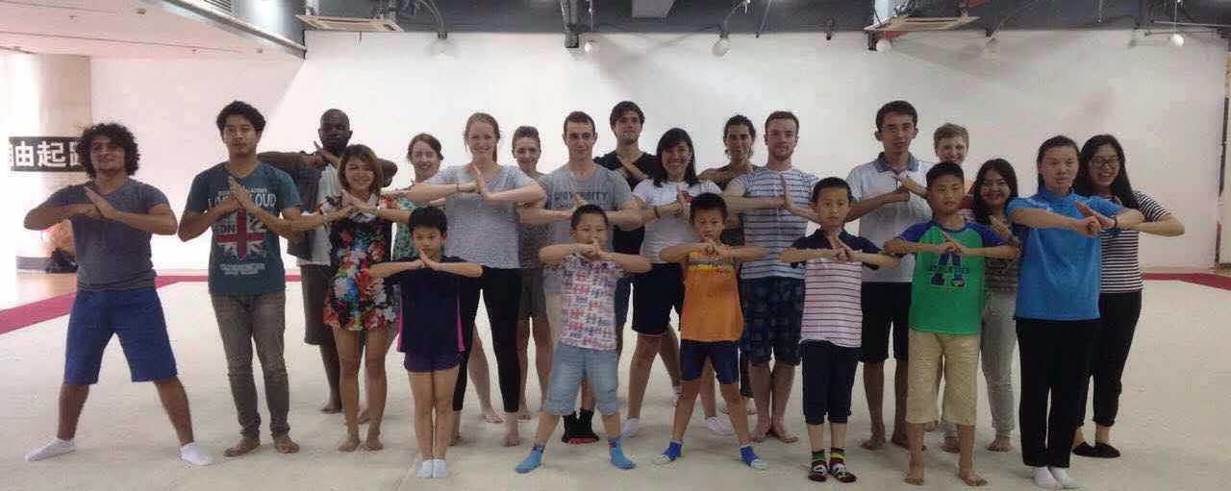
5.12 Shanghai Folk Culture Museum
Shanghai Folk Culture Museum is the platform for showcasing and communication of Chinese and foreign folk art. Different intangible cultural heritage and folk art objects from all over the world are selected and presented. Special features include Nantong Shaokouban Kite Exhibition, Personal Exhibition of porcelain.
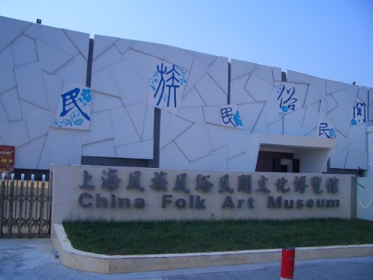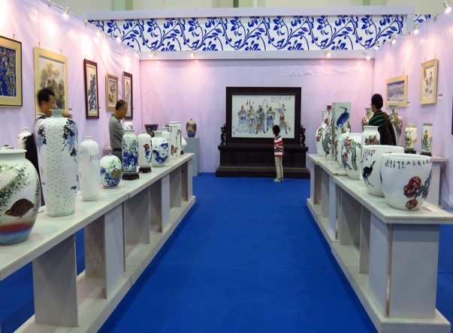
5.13 Chinese Tea Culture
Under the instruction of professors in local Tea house, students will learn the Chinese tea culture, and experience the manners of tea drinking.
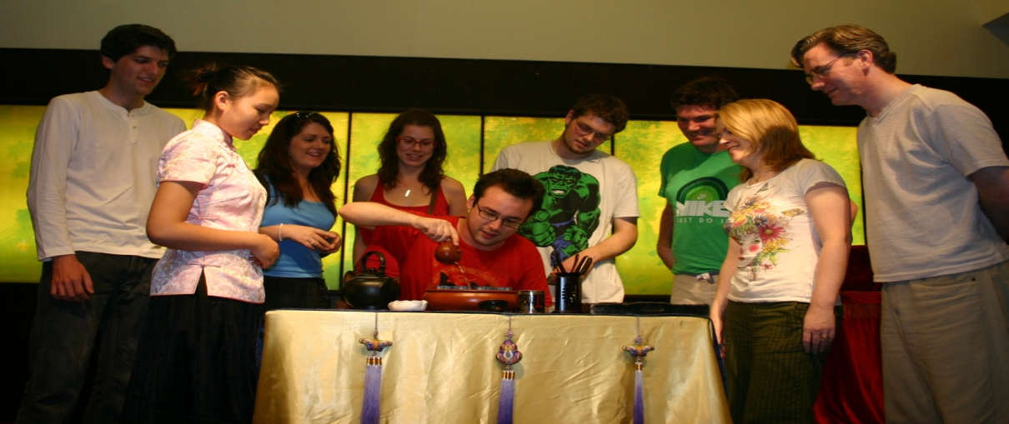
6. Contacts
Linkman: Mr. HUANG Hao, Ms. OUYANG Xiaoqin
Address: Admission Office, College of International Exchange,Shanghai University
No.149 Yanchang Road, Shanghai, 200072, P.R.China
TEL/FAX: +86-21-5633-1820/+86-21-5633-3187
E-mail: apply2@oa.shu.edu.cn
Homepage: http://www.apply.shu.edu.cn

